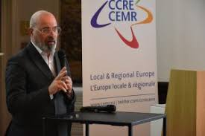
Stefano Bonaccini, President AICCRE and CEMR.

The policies put in place by the UN Agenda 2030 are now more fundamental than ever and as AICCRE, CEMR and UGLC we have always set them as necessary, starting with sustainable growth. We need to work more and more on multi-level dialogue, bringing together local authorities, governments and supranational institutions.

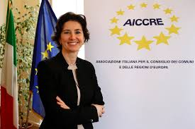
Carla Rey, Secretary general of AICCRE.

It is crucial that cities around the world can directly engage in exchange and mutual learning activities. The fragility of our system, inequalities in the world, and social vulnerabilities necessarily require interdependence between the governments and countries of the world.

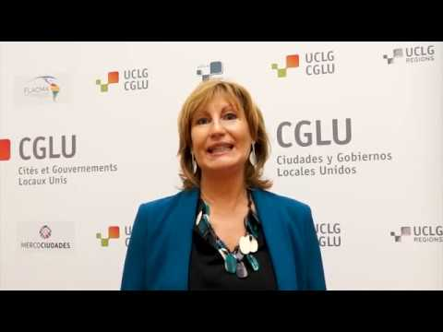
Emilia Saiz, Secretary general of UCLG

You're not going anywhere by yourself. We all need to understand this and focus on priorities. We have to start from the local to go global: that's why Global Agendas are fundamental, we have to refer to them and I think you can be a good local leader especially if you also have a role at global level.

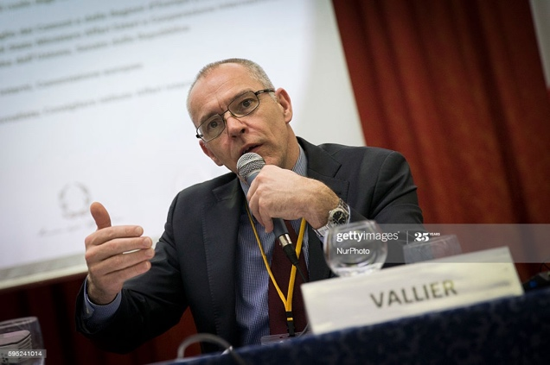
Frederic Vallier, Secretary general of CEMR
We saw during the pandemic how the role of the local regional public service was essential. What would have happened if the local public service had stopped? What saved society during this pandemic was precisely public service. This is the essential role of local and regional power, we need to rethink the model of governance, the relationship between local, regional, national and European levels.

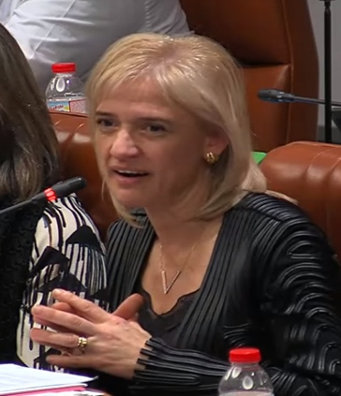
Pilar Diaz, Deputy Councillor for International Relations of the Provincial Council of Barcelona, Mayor of Esplugues de Llobregat and Representative of the Observatory for Decentralized Cooperation
Decentralised cooperation also requires us to exchange technology, because it is an area of political intervention that must focus on transforming cities and territories into something different and broader; so it is not just cooperation with cities, but we must improve public policies and transform societies.

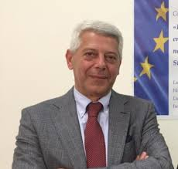
Pietro Puccio, Mayor of Capaci and spokesperson CEMR migrations
During the pandemic, an attitude that has helped a lot: the confrontation, the exchange of ideas, opinions, experiences between mayors of my territory and not only. A network of solidarity has been created and I believe that our Association, AICCRE, must focus a lot on this, to bring out more and more the need to exchange opinions, ideas, suggestions, solutions to problems.

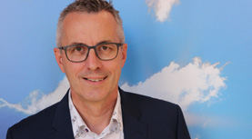
Andreas Wolter, Mayor of Köln
We have developed international cooperation with our twin cities but also with other cities that we helped in the pandemic phase, such as Peru and the Amazon forest, helping the hospitals there and local networks to organize aid to the Amazon with medicines but also with food. The German Embassy implemented the local cooperation: we also collaborated for the educational and academic system.

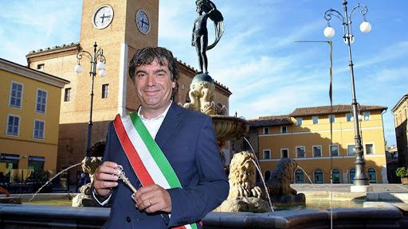
Massimo Seri, Mayor of Fano
We must improve and rethink the organisation of our cities and the reference point must always remain the Agenda 2030 on which we were working and we must continue to work, questioning and renewing ourselves. GLOBAL THINKING AND LOCAL ACTING is important. The role of local authorities is extraordinarily decisive: all the great strategies if they do not find the practical involvement of the territories do not achieve their objective.

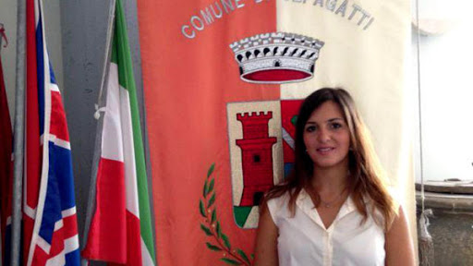
Annalisa Palozzo, deputy mayor of Ceppagatti municipality and CCRE/CEMR spokesperson on youth policy.
After Covid-19 new forms of sociality and aggregation are needed. This is very important and leads us to respect the various points of Agenda 2030, especially the one related to Objective 11, sustainable cities and communities. The community is sustainable when it has the spaces in which one can find oneself safely and with the rediscovery of large natural spaces in which to be together and in which to confront and grow.

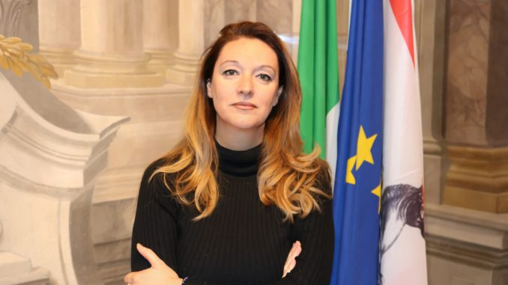
Ilaria Bugetti, regional councillor of Tuscany and CEMR spokesperson on territorial development.
During the pandemic, many of the problematic issues emerged related to the need to finance and rethink what the forces of the territory are and how the territories can improve. It is up to us to reset an even richer and more coherent agenda than it has been until now, despite the fact that we were already doing important work. Local and regional authorities need to focus on a number of SDGs: for example, 1 (combating poverty), 3 (health and well-being), 5 (gender equality) and 8 (decent work and economic growth).

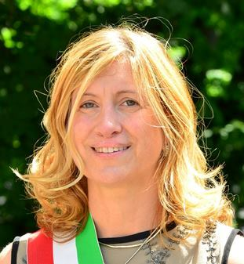
Belinda Gottardi, Mayor of Castel Maggiore and CEMR climate spokesperson
The challenge for the future is this: to manage both the health and climate crisis at the same time, thus combining and setting our theme of recovery, which we must achieve by focusing on a "green" aspect of sustainable development. Maintain the decarbonisation objective to be achieved with the timeframe we have given ourselves. The fact that today we are facing a different scenario should not be an excuse not to deal with the climate issues we were following.

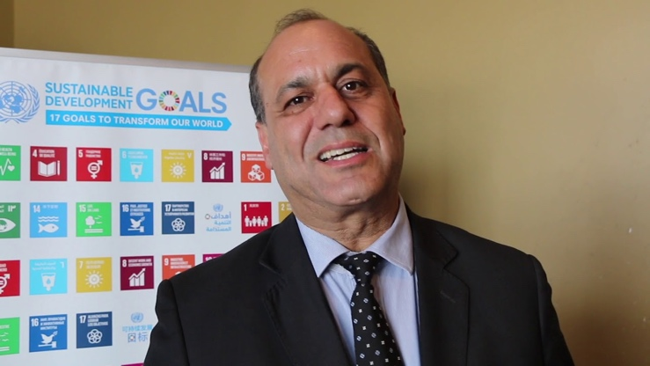
Mohamed Sefiani, Mayor of Chefchaouen, Morocco
With the 17 SDGs of Agenda2030 we have answers for everything and on post-Covid in particular. The climate, for example, is crucial; we cannot go on living without sustainable mobility, without waste recycling, without considering the climate as something transversal in our actions and to do this we must be ready, rethinking the strategy of the future. Furthermore, the health crisis and the climate crisis are linked, as is the food crisis, and cooperation between municipalities must be a reason to encourage our joint actions.

Amandine Sabourin, Platforma Policy Officer
Cities are at the forefront and play a key role in sustainability. We are working with the European Commission's DG Global to increase the dialogue between local authorities around the world. The idea is to strengthen cooperation and capacity building. There are instruments guaranteed until 2027.

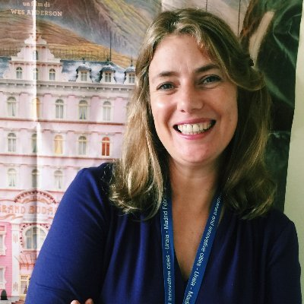
Diana Lopez, UNDP
A document has just been published by UNDP, called "A Leapfrog Mission", which focuses on five fronts of action affecting the territories: the protection of health services, the expansion of social protection of essential services, the protection of labour, small and medium-sized enterprises and supply chains, making fiscal and financial resources available for the response and strengthening the social issue and community action.

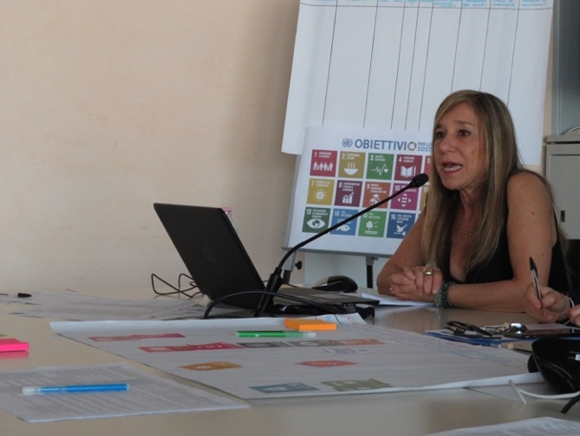
Anna Lixi, Team Leader, DG DEVCO
In the last two years we have promoted decentralised cooperation, promoting partnerships between the so-called local authorities of the north of the European Union countries and the local authorities of the partner countries. We have refocused funds from the thematic line to the Brussels level for the benefit of local authorities and have therefore launched a call for proposals highlighting the importance of creating partnerships between local authorities in the European Union and partnerships of local authorities with third countries. We financed the first sixteen partnerships and we are now assessing, in the middle of the evaluation process, new partnerships on the basis of a second call.

