EQUALITY UPDATE
Issue n°1, January 2020
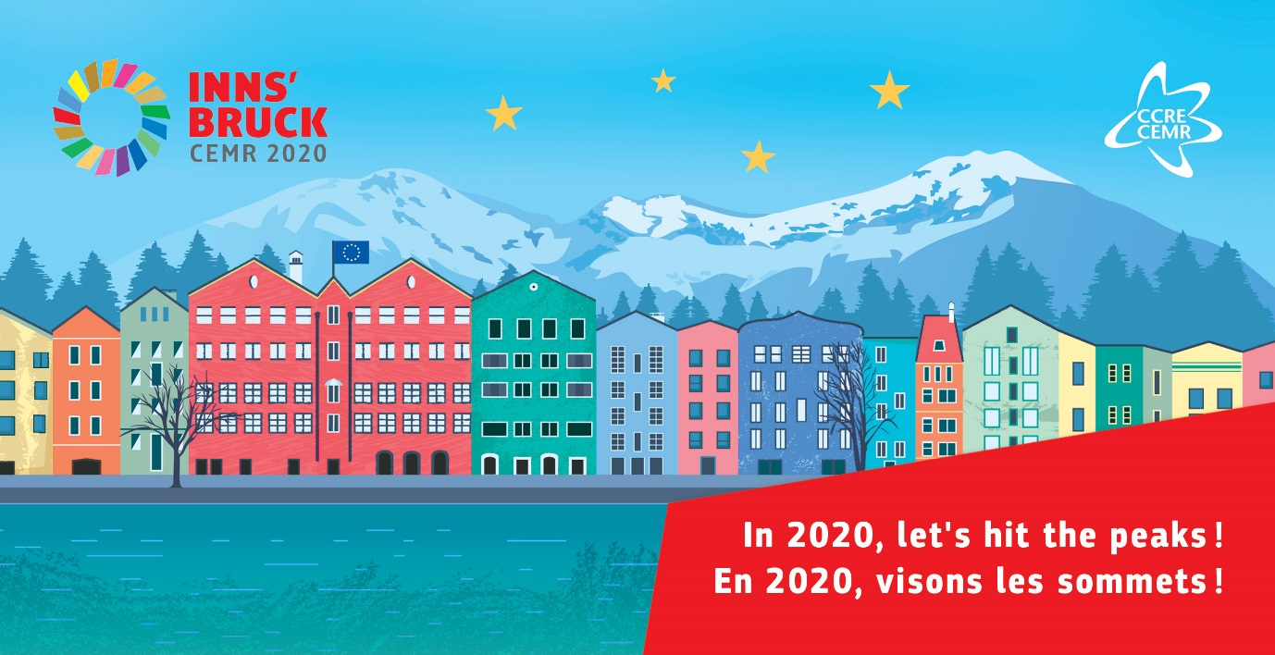
CEMR NEWS

This first edition of the CEMR Equality update in 2020 is packed with a lot of information, catching up on some news items from late 2019 and looking forward to the many activities in store over the next months. Happy New Year, Happy Reading!

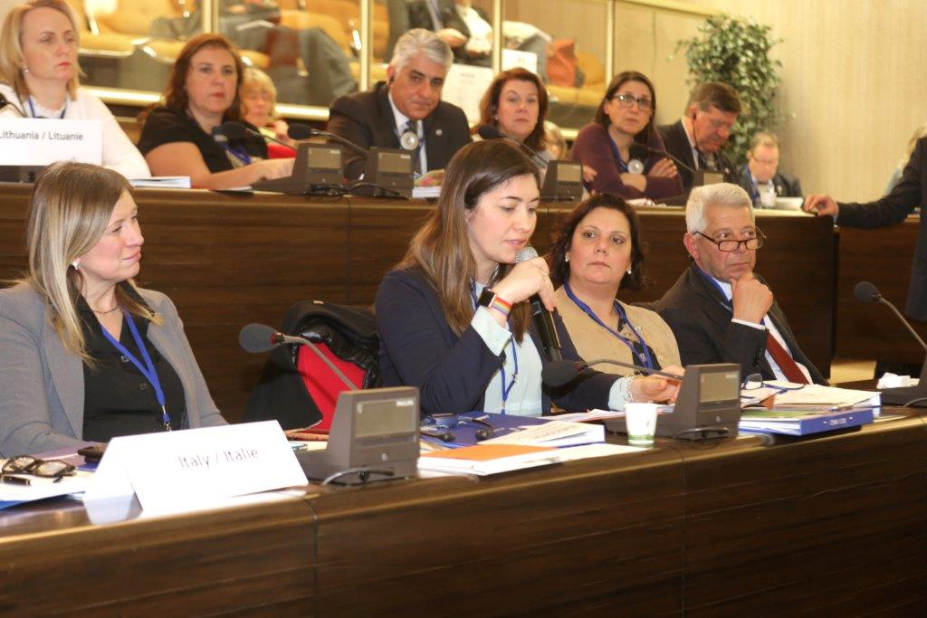
Welcome to the new Co-Chair of the CEMR Standing Committee for Equality, Silvia Baraldi

For information
Silvia Baraldi, Municipal Councillor of Legnago, Italy (AICCRE) was officially nominated as the Co-Chair of the CEMR Standing Committee for Equality by the Policy Committee in Orléans on 23 January. She will become Chair of the Committee in 2021.

2020 meetings- CEMR Standing Committee for Equality & gender equality expert group
For information
- 28-29 April: Please note that a breakfast meeting with MEPs of the FEMM Committee is foreseen on either 28/04 or 29/04 and the Chair of the Standing Committee will present CEMR’s study “Women in politics: Local and European Trends” to the FEMM Committee during their meeting on 28/04 (am). The CEMR Standing Committee for Equality and gender equality expert group meeting will continue on 29/04 in the first half of the day.

Draft agenda to be sent in early February.

- 16-17 September: Note: The meeting will begin on 16/09 in the afternoon and continue on 17/04.

- *Please note that depending on registered participants to the Innsbruck Congress, an opportunity for Standing Committee members to meet may be proposed between 6-8 May.

For action
- Please register for the 28-29 April meeting via the following link (deadline to register 23 April): https://forms.gle/2yx4ovZUEZjYvRdZ8

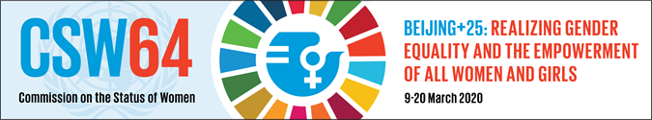
CEMR/PLATFORMA, local governments prepare for the 64th UN Commission on the Status of Women (CSW64)
For information
This year the 64th UN Commission on the Status of Women (9-20 March 2020 in New York) will mark the 25th anniversary of the Beijing Declaration and Platform for Action, taking stock of the achievements and gaps in its critical areas of concern, as well as the five-year milestone for the SDGs.
As part of their ongoing activities to promote gender equality mainstreaming and women’s empowerment in town-to-town and region-to-region cooperation for development, the PLATFORMA Secretariat and several partners plan on participating in CSW64: CEMR, DIBA: Province of Barcelona, VVSG: Belgium, NALAG: Georgia, SALAR: Sweden.
CEMR and PLATFORMA will organise a parallel session at CSW64 entitled “Going local: Women’s representation and international cooperation for gender equality” on Thursday, 12 March from 8:30-10:00am at the Church Center for the United Nations (Drew Room).
Key topics to be addressed in the session include:
- Findings of the 2019 CEMR study “Women in Politics: Local and European Trends”
- European Charter for Equality of Women and Men in Local Life (the tool, good practices, link to SDGs)
- Project for an African Charter for Local Equality w/ UCLG Africa/REFELA (international cooperation on gender equality between networks of local elected women)
A detailed concept note and draft programme are currently in preparation and will be shared with partners in February.
-
A high-level political event sponsored by the Swedish government will be organised by SALAR, CEMR and UCLG Africa (to be confirmed) on 11 March from 15:00-16:30. The session, "Global challenges - local solutions" will take in the Swedish Permanent Representation or in the UN building and will be an invitation-only event.

OTHER LRG ACTIVITIES AT CSW64
- CEMR/PLATFORMA are currently looking into the organisation of a breakfast meeting between European local elected representatives and the EU political representatives at the EU delegation to the UN. The planning of this activity is still in process and not yet confirmed.
- UCLG proposes a "Local and Regional Development Day for Gender Equality", the date is not yet confirmed but they are aiming for Friday, 13 March.

For action
- If your organisation or your members will be present at CSW64 in March, please inform Jaimie Just, CEMR Policy Officer – Gender equality and Diversity (jaimie.just@ccre-cemr.org) who is responsible for coordinating our activities and representatives.
UCLG statement to UN CSW64 for input
As part of the mobilisation and raising up the voice of LRGs for CSW64, UCLG has a draft statement addressed to the national governments and the UN concerning CSW64/ 25th anniversary of the Beijing Declaration and Platform for Action. A first version was adopted by the representatives of the UCLG World Congress in Durban last November.
- Please find attached the draft statement text that UCLG is circulating for input. We invite you to provide your feedback and any suggested modifications (please activate track changes and use comment boxes within the document) then CEMR/PLATFORMA will centralise the input of our member associations for submission to UCLG. Deadline to provide input to me is 30/01, no exceptions.

Invitation to an open exchange on Istanbul Convention monitoring and reporting responsibilities - hosted by CEMR with the City of Frankfurt on 31 January 2020
For information
As a follow-up to an issue raised in the last joint meeting of the Standing Committee and expert group, CEMR and the City of Frankfurt will organise an open online exchange about monitoring and reporting responsibilities of the Istanbul Convention. The target participants are experts and practitioners actively involved in the implementation and/or monitoring of the Istanbul Convention, both from the local/regional and national level. The webinar will provide a space for them to share their experiences and identify common challenges faced in monitoring the implementation of the Convention on the ground and possible ways forward.

For action
- Register to participate in the virtual discussion by 30/01 using the following link: https://forms.gle/rd4UynXY3apViG2D6. Once registered, participants will receive a link to join the virtual meeting.

- Please circulate information on the virtual exchange to your network (background note with discussion questions in attachment).

Final version of the CEMR study “Women in Politics: Local and European Trends” launched at the CEMR retreat in November
Thanks to many months of hard work and the engagement of our member associations, the 2019 study on women in politics has been published!

A first debate was held to launch the publication at CEMR’s Retreat on 5 November. Emil Broberg, Chair of the Standing Committee for Equality, Luzette Kroon, Mayor of Waterland, Robert Biedron, Vice-Chair of the FEMM Committee of the European Parliament and MEP Lina Gálvez Muñoz discussed the findings of this ground-breaking study and how to increase the number of women in politics.

CEMR news: https://www.ccre.org/en/actualites/view/3943
Study EN: http://bit.ly/2JJmi6X
Study FR: http://bit.ly/36AbSA8

MEMBERS SECTION
Network of women local leaders founded in Finland with support from AFLRA
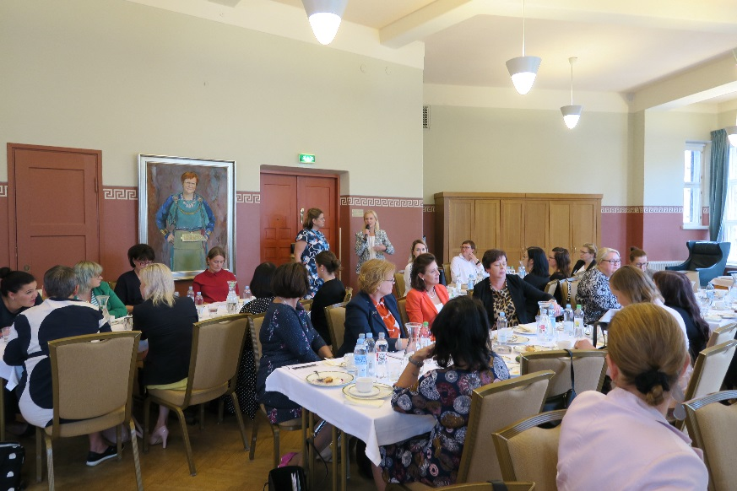
A network of the CEOs of Finnish municipalities and cities was founded in 2019. Currently there are 310 municipalities in Finland and 25 % of the CEOs are women. The establishment of the network was inspired by the campaign of 100 deeds of gender equality in connection with 100 years of Finland’s Independence.

The priorities include leadership, mentoring and promotion of gender equality at local level. Benchmarking local leadership in other countries and the work of similar networks are also key areas of interest for the group of women CEOs.

The network has had a couple of meetings, the first meeting was arranged by the City of Vantaa and the second one by the Association of Finnish Local and Regional Authorities. The City of Tampere has invited the network to its next meeting on 22 April 2020.
Meeting of the Finnish network of women local leaders. Note: The painting on the wall is of Tarja Halonen, the first female president of Finland.

For more information, contact: Sinikka Mikola, sinikka.mikola@kuntaliitto.fi ;tel. +358 50 342 8218.

“Sexism and gender-based violence in politics”
For information
In recent years, a rising tide of women’s activism has swept across the world. Online and on the streets, millions of women have raised their voices and called for action against systemic abuse, harassment, and discrimination, as we reference in our 2019 study “Women in Politics: Local and European Trends”.

However, politically motivated attacks on women have been on the rise in nearly every region of the world, reaching a record high in 2019, according to the Armed Conflict Location and Event Data Project. These are the results of an analysis published in an article by Foreign Affairs.

To look at the local/regional dimension of this phenomenon, Jelena Drenjanin, Spokesperson for Gender Equality of the Congress of the Council of Europe, City Councillor of Huddinge, member of Committee of the Regions, has prepared a report on “Sexism and gender-based violence in politics” a for the Congress of Local and Regional Authorities of the Council of Europe. A debate and vote on the draft resolution and draft recommendation will take place on 16 March at the 38th session of the Congress (17-19 March) in Strasbourg. CEMR’s President, Stefano Bonaccini, will make a statement during the session.

Charter signatory Zhytomyr’s “She Week for Democracy Development” project on gender equality (Ukraine)
For information
From 5-12 September 2019, the City of Zhytomyr, with the support of the Association of Ukrainian Cities and the Canadian PROMIS project, organised the first “She Week for Democracy Development”.
Many activities were proposed during the week including:
- A Citizen consultation in support of a new development programme for the city “Zhytomyr - the city of equal opportunities”
- Organisation of an art therapy workshop for internally displaced women and those who were temporarily in difficult circumstances
- “She Week” open air forum
- A business breakfast to link women entrepreneurs and mentors
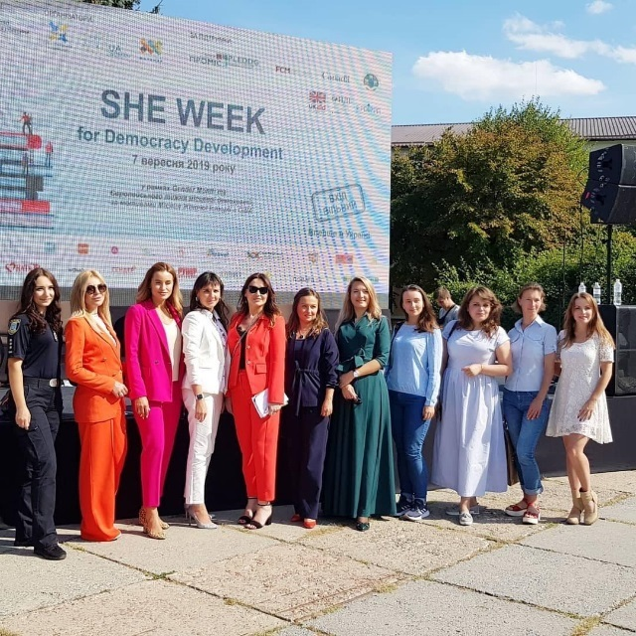
- Several workshops around the themes of “Women in Education and Science”; “Women in Politics”; “Women in business”; "We are different - we are equal"; “Gender sensitive communication” with students, journalists and advertisers; breaking gender stereotypes in professions; and even on the English language.
- A roundtable meeting on “Mechanism of Quality Response to Domestic and Gender-Based Violence”
- Cooperative Training workshop with police officer tackling concepts such as "gender equality", "equal opportunities", "feminism", "LGBT community".
- Television broadcast and discussion on “She Week”
For more information about Zhytomyr’s gender equality projects, contact City Councillor Iryna Yarmolenko: irena.yarmolenko@gmail.com
She Week photo album
EUROPEAN CHARTER FOR EQUALITY - NEW SIGNATORIES
In the months since the last edition of the Equality Update, 22 municipalities/regions have adhered to the European Charter for Equality of Women and Men in Local Life, bringing the total number of signatories to 1,807 in 36 countries. More information on Charter signatories, their action plans and good practices are available on the Observatory website (*please note that the Observatory is currently undergoing maintenance and new signatories will be added shortly).

Country | Municipality/Province/Region | Date
Croatia | Dubrovnik | 30/09/2019
Croatia | Labin | 11/11/2017
Finland | Kronoby | 04/10/2019
France | Corsica | 21/05/2019
France | Rodez | 11/10/2019
France | Pré Saint-Gervais | 04/07/2019
France | Communauté d'Agglomération Saint-Avold Synergie | 04/10/2019
Georgia | Kutaisi | 24/09/2019
Georgia | Lagodekhi | 24/09/2019
Georgia | Ozurgeti | 24/09/2019
Georgia | Rustavi | 24/09/2019
Germany | Lübeck | 20/12/2019
Lithuania | Druskininkai | ?
North Macedonia | Makedonska Kamenitsa | 11/04/2018
Serbia | Novi Bečej | 18/11/2019
Sweden | Östersund | 17/10/2019
Sweden | Söderköping | 31/10/2019
Sweden | Västernorrland | 16/10/2019
Sweden | Motala | 19/12/2019
Turkey | Izmir-Karşıyaka | 27/12/2019
Ukraine | Bobrynets | ?
Ukraine | Omelnyk | 19/02/2019

EUROPEAN AFFAIRS
European Commission Roadmap for the gender equality strategy 2020-2024
For information
A Union of Equality is one of the major priorities of the new Commission, based on the principle of equality for all and equality in all of its senses. In her political guidelines, President von der Leyen announced a new European Gender Equality Strategy, and the mission letter of Equality Commissioner, Helena Dalli, tasks her with the development of this Strategy to address areas in which women still face barriers.

This Roadmap aims to inform citizens and stakeholders about their work in order to allow them to provide feedback and to participate effectively in future consultation activities. Citizens and stakeholders are in particular invited to provide views on the Commission's understanding of the problem and possible solutions and to make available any relevant information that they may have.

Open: 16 January 2020 - 13 February 2020 (midnight Brussels time)

For action
- Please review the roadmap document and send me your input/suggestions/comments by 10/02.

FEMM Committee report on the upcoming EU gender equality strategy
The FEMM Committee of the European Parliament will wait for the Commission to publish its draft EU Gender equality strategy in early March before taking up the file. The rapporteur is Maria Noichl (S&D, DE).

The proposed timeline for the report within the FEMM Committee is:
- Consideration of draft report - 16 April 2020
- Deadline for tabling amendments - 22 April 2020
- Consideration of amendments - 28 Mai 2020
- Vote FEMM - 23 June 2020
- Vote plenary - tbc

More information will be provided once the draft strategy is published. Members will be invited to provide input to CEMR’s proposed amendments.

Understanding the gender pay gap: definition and causes
For information
Although the equal pay for equal work principle was already introduced in the Treaty of Rome in 1957, the so-called gender pay gap stubbornly persists with only marginal improvements being achieved over the last ten years. The European Parliament has consistently called for more action to narrow the gap and again discussed the matter during a plenary debate on Monday 13 January. Have a look at a closer explanation of the matter here.

European Commission ROADMAP for feedback on Strengthening the principle of equal pay between men and women through pay transparency
The ROADMAP is open 06 January 2020 - 03 February 2020 (midnight Brussels time)
This file is shared with the CEMR expert group of LRGs as employers, who adopted a position in April 2019 (“CEMR answer to the public consultation on the Evaluation of the relevant provisions of EU law implementing the Treaty principle on 'equal pay for equal work or work of equal value”-in attachment).

For action
- Please consult the April 2019 position and add your input and suggested modifications by the end of this week if possible.

Croatian Presidency outlines priorities to EP Committees
FEMM
On Wednesday, Demography, Family, Youth and Social Policy Minister Vesna Bedeković, told Women’s Rights and Gender Equality MEPs that the main priority in terms of gender equality is to identify the obstacles women face on the labour market and increase their rate of activity. ‘‘Stronger economic independence for women is key for economic growth’’, she said. The Minister also declared she would work to reduce the gender pay and pension gaps.

MEPs quizzed the Minister on a number of additional issues such as the attacks on sexual and reproductive rights in some EU countries, the ratification of the Istanbul Convention on preventing and combating violence against women (only 21 EU countries have ratified it) and the Women on boards Directive, which is blocked in the Council.

Employment and Social Affairs
Labour and Pension System Minister Josip Aladrović and Social Policy Minister Vesna Bedeković outlined on Wednesday to the Employment and Social Affairs Committee their priorities for the next six months. These include delivering on the European Pillar of Social Rights as well as promoting work-life balance, gender equality and increased participation of women in the labour market. The implementation of the Convention on the Rights of Persons with Disabilities (CRPD) will be also high on the agenda.

MEPs quizzed the ministers on youth unemployment and the future of the youth guarantee, and the role of social partners in setting up an EU minimum wage. They expressed concerns about the funding of the European Pillar of Social Rights and the future Child Guarantee, announced for 2021. Several MEPs finally quizzed the ministers on the negotiations on the future EU long-term budget, opposing possible transfers from cohesion funds to the Just Transition Fund.

Details on presentations made in other committees can be found here: https://www.europarl.europa.eu/news/en/press-room/20200123IPR70918/croatian-presidency-outlines-priorities-to-ep-committees

Croatian Presidency event - EU Conference on Gender Equality: Participation of women on the labour market – Benefit for society!
For information
Croatia will organise a conference to analyse the existing obstacles to the full participation of women in the labour market, taking into account elements such as the lack of accessible quality care for dependent and ill family members, the lack of specific skills in the labour market, precarious and atypical forms of employment, and the risk of workplace harassment. It will propose conclusions determining the correlation between the participation of women in the labour market and the obligations of long-term care for dependent family members.

Renew Europe wants to build the ‘Simone Veil-Pact’
For information
As an activist and women’s rights campaigner, ground-breaking politician and committed European, Simone Veil’s work stands for respect for human dignity and human rights, freedom, democracy and equality. The Renew Europe Group aims to honour her legacy by building the ‘Simone Veil-Pact’ – a political commitment by Member States to adopt the most progressive national measures currently in force in the field of women’s rights and gender equality in the EU. MEPs Nathalie Loiseau, Sophie in't Veld and Irène Tolleret hosted the first kick-off event on 7 January to discuss and build upon the idea of the ‘Simone Veil-Pact’.

Gender equality at the European Week of Regions and Cities 2019
For information
The work on Gender Equal Cities that CEMR did in collaboration with URBACT was followed up in a session at the 2019 EWRC entitled “How gender equal is your city and region? Where are women in Europe thriving?”

The session showcased ways in which local authorities can bring about positive change through prioritising and mainstreaming gender-sensitive policymaking. The new EU regional gender equality monitor was presented that answers two questions: How big is the disadvantage of women relative to the men in their region? How much lower are the achievements of women relative to the region with the highest performing women?

Examples from front runner cities documented in the URBACT Gender Equal Cities, such as Umeå, were presented.

Lena Wängnerud of the University of Gothenburg also presented fascinating research looking at the question “Does gender equality reduce corruption?”

A full summary of the session and links to speakers’ presentations available here: https://europa.eu/regions-and-cities/programme/sessions/649_en

OTHER NEWS
Report of the Beijing+25 UNECE Regional Review Meeting (October 2019, Geneva)
For information
The Beijing Declaration and Platform for Action of 1995 is the most ambitious road map for the empowerment of women and girls everywhere. In 2020, it will be 25 years since the Beijing Platform for Action set strategic objectives and actions for the achievement of gender equality in 12 critical areas of concern.

The Beijing+25 Regional Review Meeting which took place on 29-30 October 2019 in Geneva, provided a forum for UNECE member States to review progress and identify challenges in the implementation of the Beijing Platform for Action.
Here you can have a look at the regional review report that will feed into the discussions and negotiations at UN CSW64 in March 2020.

UN Women Generation Equality Forum Launch on 7-8 May & 7-10 July 2020
For information
The UN Women Brussels Office announced the launch of the momentous Generation Equality Forum, a civil society-centred, global gathering for gender equality, co-hosted by the governments of Mexico and France. Kicking off in Mexico City, Mexico on 7-8 May 2020, the Forum will culminate in Paris, France on 7-10 July 2020.

The Generation Equality Forum will celebrate the historic 25th anniversary of the fourth World Conference of Women and the adoption of its landmark outcome framework for gender equality and women’s rights, the Beijing Platform for Action. In addition to celebrating progress on the gender equality agenda, the Forum will foster a global public conversation for urgent action and accountability for key challenge areas that will unlock important progress for women’s rights.
At the end, the Forum will set in motion concrete, ambitious and transformative actions to achieve immediate and irreversible progress towards gender equality over the next 5 years.

Report on monitoring the Istanbul Convention implementation of European countries
For information
GREVIO is the independent expert body responsible for monitoring the implementation of the Council of Europe Convention on Preventing and Combating Violence against Women and Domestic Violence (Istanbul Convention) by the Parties. GREVIO drew up and published reports evaluating legislative and other measures taken by the Parties to give effects to the provisions of the Convention.

Publication ‘Gender just climate solutions’ by WUNRN
For information
Last December, The Women and Gender Constituency (WGC) published the 5th edition of ‘Gender just Climate solutions’. It recognises “technical”, “non-technical” and “transformational” solutions to climate challenges which have both a gender and climate impact, sustainable and scalable/replicable.

The Women and Gender Constituency (WGC) is one of the nine stakeholder groups of the United Nations Framework Convention on Climate Change (UNFCCC). Established in 2009 and granted full constituency status in 2011, the WGC consists of 29 women’s and environmental civil society organizations, who are working together to ensure that women’s voices are heard and their rights prioritized in the fight against climate change. The Women and Gender Constituency, consisting of a broad variety of national and regional network organizations, represents hundreds and thousands of people across the globe, with advocates from over 60 countries.

‘Global gender gap report 2020’ by the World Economic Forum
For information
At the current rate of change, we will not see gender parity in our lifetimes, and nor likely will many of our children. That’s the sobering finding according to the World Economic Forum’s ‘Global gender gap report 2020’ which reveals that gender parity will not be attained within the next 99.5 years!
EVENTS / DATES TO REMEMBER
31 January EU Conference on Gender Equality: Participation of women on the labour market – Benefit for society! – Zagreb, Croatia
18 February CEMR gender equality workshop at PLATFORMA Coordination seminar – Tbilisi, Georgia
18 February FEMM Committee meeting

5 March CEMR joint event with Committee of the Regions “Women and Politics: overcoming the gender gap” – Brussels

9-20 March CSW64 – New York

28-29 April Joint meeting of CEMR Standing Committee for Equality and gender equality expert group

6-8 May CEMR Congress – Innsbruck, Austria

7-8 May Generation Equality Forum – Mexico City, Mexico
7-10 July Generation Equality Forum – Paris, France
CONTACT FOR FURTHER INFORMATION
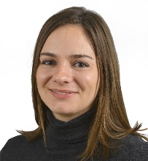
Jaimie Just, Policy Officer – Gender Equality and Diversity
(+32) 2 500 05 49
@ Jaimie.Just@ccre-cemr.org
Skype: jaimie.just.ccre
Twitter: @CEMR_Equality

